**Supplemental Materials**

**Does Cognitive Ability Buffer the Link Between Childhood Disadvantage and Adult Health?**

**by E. Bridger & M. Daly, 2017, *Health Psychology***

**http://dx.doi.org/10.1037/hea0000538**

Table S1: *Questions and response options for childhood social disadvantage measures in the two cohorts.*

|  |  |  |
| --- | --- | --- |
|  | NCDS | BCS |
| Tenure | | |
|  | Age 7 | Age 5 |
|  | Is the accommodation: | Is the accommodation owned or rented by the household? |
|  |  |  |
|  | Owner Occupied or being bought? | Owned Outright |
|  | Council Rented? | Being Bought |
|  | Private Rented? | Rented from council |
|  | Rent free? | Privately rented unfurnished |
|  | Other (please specify) | Privately rented furnished/partly furnished |
|  |  | Tied to Occupation of Father |
|  |  | Other |
|  |  |  |
| Crowding | | |
|  | Age 7 | Age 5 |
|  | Number of Persons per Room: | Persons per room ratio |
|  |  |  |
|  | Up to 1 person per room |  |
|  | 1.01  – 1.50 persons per room |  |
|  | 1.51 – 2.00 persons per room |  |
|  | Over 2 persons per room |  |
|  |  |  |
| Father Education | | |
|  | Age Father left School (recoded as categorical variable with following categories <13, 13-14, 14-15, 15-16, 16-17, 17-18, 18-19, 19-21, 21-23, >23 years) | At what age did the father leave school? |
|  |
|  |
|  |  |
|  |  |
|  |  |  |
| Mother Education | | |
|  | Age Mother left School (recoded as categorical variable with following categories <13, 13-14, 14-15, 15-16, 16-17, 17-18, 18-19, 19-21, 21-23, >23 years) | At what age did the mother leave school? |
|  |
|  |
|  |  |
|  |  |
|  |  |  |
| Social Class | | |
|  | For both cohorts and time points the following Registrar General’s Social Classes categories were used (based on the Father's/Mother's husband's occupation) | |
|  | I, Professional Occupations | |
|  | II, Managerial/Technical Occupations | |
|  | IIInm, non-manual Skilled Workers | |
|  | IIm, manual Skilled Workers | |
|  | IV, Semiskilled Workers | |
|  | V = Unskilled Workers | |
| Social Class at Birth | | |
|  | What was the husband's occupation at the time of birth? | Occupation of [Mother's] Husband |
|  |  |  |
| Social Class at Early Childhood | | |
|  | Age 7 | Age 5 |
|  | What is the occupation of the child's father? (i.e. present male head of household) | What is the father's actual job, occupation, trade or profession, or the last occupation if unemployed or retired? |

Table S2: *Descriptive statistics for predictor variables and the measures used to assess childhood social disadvantage in the NCDS and BCS cohorts.*

|  |  |  |  |
| --- | --- | --- | --- |
|  |  | NCDS | BCS |
|  |  | (N = 13,213) | (N = 11,522) |
| Female (%) |  | 48.8% | 48.6% |
| Cognitive ability |  | 43.26 (16.00) | 59.64 (13.37) |
| Social disadvantage: |  |  |  |
| Father’s education |  |  |  |
| <14 years |  | 1.5% | 0.6% |
| 14-16 |  | 55.2% | 63.7% |
| 16-18 |  | 9.5% | 19.0% |
| 18-21 |  | 3.0% | 6.3% |
| >21 years |  | 2.6% | 6.1% |
| Measure unavailable |  | 28.1% | 4.3% |
| Mother’s education |  |  |  |
| <14 years |  | 1.1% | 0.8% |
| 14-16 |  | 56.7% | 65.7% |
| 16-18 |  | 11.7% | 22.9% |
| 18-21 |  | 2.6% | 6.1% |
| >21 years |  | 1.4% | 3.4% |
| Measure unavailable |  | 26.5% | 1.1% |
| Social class at birtha |  |  |  |
| I |  | 3.8% | 4.7% |
| II |  | 12.1% | 12.7% |
| III |  | 56.4% | 59.5% |
| IV |  | 11.5% | 16.5% |
| V |  | 8.8% | 6.2% |
| Measure unavailable |  | 7.4% | 0.5% |
| Social class in early |  |  |  |
| childhooda |
| I |  | 4.7% | 5.1% |
| II |  | 13.4% | 16.1% |
| III |  | 50.9% | 46.2% |
| IV |  | 16.5% | 11.3% |
| V |  | 6.1% | 4.1% |
| Measure unavailable |  | 8.3% | 17.3% |
| Tenureb |  |  |  |
| 1 |  | 39.7% | 48.8% |
| 2 |  | 11.3% | 5.1% |
| 3 |  | 38.4% | 28.0% |
| 4 |  | 2.1% | 3.2% |
| Measure unavailable |  | 8.4% | 15.0% |
| Crowding |  |  |  |
| (people per room) | 1.14 (.47) | .89 (.32) |
| Measure unavailable | 9.0% | 15.1% |

*Note.* Numbers are either percentages or means (standard deviation).

a Social Class derived from father’s occupation: I = professional occupations, II = managerial or technical occupations, III = skilled workers, IV = semiskilled workers, V = unskilled workers.

b Tenure ranked as 1 = owner occupied or being bought, 2 = private rented furnished or unfurnished, 3 = council rented, 4 = rent free (NCDS) or tied to occupancy (BCS).

Table S3: *Questions and response options for social disadvantage measures in adulthood for the two cohorts.*

|  |  |  |
| --- | --- | --- |
|  | NCDS | BCS |
| Social Class | For both cohorts the Registrar General’s Social Classes categories were used (based on the cohort member’s current or most recent occupation) a | |
|  | I, Professional Occupations | |
|  | II, Managerial/Technical Occupations | |
|  | IIInm, non-manual Skilled Workers | |
|  | IIm, manual Skilled Workers | |
|  | IV, Semiskilled Workers | |
|  | V = Unskilled Workers | |
|  |  |  |
| Tenure | Is current accommodation owned or rented?b | Do you own current your home or have some other arrangement?b |
|  | Own - outright | Own - outright |
|  | Own - mortgage | Own - with help of a mortgage |
|  | Shared ownership | Pay part rent/part mortgage |
|  | Rent it | Rent it |
|  | Squatting | Live here, rent-free |
|  | Other | Squatting |
|  |  | Other |
|  |  |  |
| Crowding | Number of rooms [bedrooms + bedsits + living rooms + other rooms] / Household size | Persons per room ratio |
|  |  |  |
| Education | Age when left full-time continuous education | How old were you when you first left full-time education? |

a Social Class recoded to: I = professional occupations, II = managerial or technical occupations, III = skilled workers, IV = semiskilled workers, V = unskilled workers

b Tenure recoded to: 1 = Own - outright, 2 = Own - buying with mortgage, 3 = Part rent, part mortgage, 4 = Rent, 5 = Rent-free

Table S4: *Correlations between all principal variables in the two cohorts (NCDS above the diagonal, BCS below the diagonal). All correlations are statistically significant at p<.001.*

|  |  |  |  |  |  |  |  |  |  |  |
| --- | --- | --- | --- | --- | --- | --- | --- | --- | --- | --- |
|  | Cognitive Ability | Social Disadvantage | Psych Distress S1 | Psych Distress S2 | Psych Distress S3 | Psych Distress S4 | SRH S1 | SRH S2 | SRH S3 | SRH S4 |
| Cognitive Ability |  | -.405 | -.116 | -.104 | -.111 | -.099 | .078 | .114 | .101 | .163 |
| Social Disadvantage | -.383 |  | 0.12 | .075 | .093 | .090 | -.094 | -.125 | -.114 | -.174 |
| Psych Distress S1 | -.204 | .143 |  | .571 | .505 | .456 | -.331 | -.231 | -.181 | -.230 |
| Psych Distress S2 | -.170 | .104 | .510 |  | .588 | .493 | -.248 | -.308 | -.241 | -.248 |
| Psych Distress S3 | -.112 | .073 | .432 | .533 |  | .569 | -.226 | -.249 | -.340 | -.298 |
| Psych Distress S4 | -.130 | .078 | .403 | .485 | .582 |  | -.207 | -.207 | -.239 | -.374 |
| SRH S1 | .115 | -.085 | -.322 | -.219 | -.177 | -.175 |  | .454 | .351 | .386 |
| SRH S2 | .169 | -.147 | -.238 | -.342 | -.240 | -.233 | .401 |  | .426 | .443 |
| SRH S3 | .184 | -.147 | -.226 | -.264 | -.362 | -.286 | .328 | .468 |  | .467 |
| SRH S4 | .197 | -.174 | -.212 | -.237 | -.289 | -.404 | .289 | .428 | .540 |  |

Table S5: *Conditional effect of Social Disadvantage at each level of Cognitive Ability: Low Cognitive Ability (-1 SD), Medium Cognitive Ability (Mean) and High Cognitive Ability (+1 SD), for Model 2.*

|  |  |  |  |  |  |  |  |
| --- | --- | --- | --- | --- | --- | --- | --- |
|  |  | Psychological Distress | | | Self-rated Health | | |
| Cohort | Age | Low Cog Ability | Medium Cog Ability | High Cog Ability | Low Cog Ability | Medium Cog Ability | High Cog Ability |
| NCDS | 23 | .138*** (.015) | .077*** (.010) | .017 (.013) | -.075*** (.016) | -.051*** (.011) | -.027 (.014) |
|  | 33 | .082*** (.016) | .042*** (.011) | .001 (.014) | -.122*** (.017) | -.109*** (.011) | -.095*** (.015) |
|  | 42 | .080*** (.017) | .035** (.011) | -.010 (.014) | -.136*** (.017) | -.101*** (.011) | -.066*** (.014) |
|  | 50 | .086*** (.018) | .030* (.012) | -.027 (.016) | -.144*** (.017) | -.124*** (.012) | -.104*** (.016) |
| BCS | 26 | .170*** (.021) | .112*** (.014) | .052** (.016) | -.086*** (.022) | -.077*** (.015) | -.068*** (.017) |
|  | 29 | .092*** (.019) | .049*** (.013) | .007 (.015) | -.149*** (.019) | -.111*** (.013) | -.074*** (.015) |
|  | 34 | .111*** (.020) | .069*** (.014) | .026 (.016) | -.125*** (.021) | -.101*** (.014) | -.077*** (.016) |
|  | 42 | .113*** (.021) | .065*** (.014) | .017 (.017) | -.188*** (.020) | -.148*** (.014) | -.109*** (.016) |
| Standard errors in parentheses. * p<.05,** p<.01, *** p<.001 | | | | | | | |

Table S6: *Regression outcomes for predicting Psychological Distress at age 42 in the BCS cohort with adjustments for social disadvantage in adulthood*

|  |  |  |  |  |  |  |
| --- | --- | --- | --- | --- | --- | --- |
| Psychological Distress at age 42 | | BCS | | | | |
|  |  | 1 | 1 + Social Class | 1 + Tenure | 1 + Crowding | 1 + Education |
|  | Social Disadvantagea | .072*** (.015) | .056*** (.015) | .059*** (.015) | .072*** (.015) | .060*** (.016) |
|  | Cognitive Abilitya | -.081*** (.014) | -.061*** (.014) | -.067*** (.014) | -.080*** (.014) | -.072*** (.014) |
|  | Interaction | -.048*** (.013) | -.039** (.013) | -.042** (.013) | -.048*** (.013) | -.051*** (.013) |
|  | Female | .205*** (.025) | .157*** (.025) | .207*** (.025) | .205*** (.025) | .207*** (.025) |
|  | Social Class at 42a |  | .017 (.009) |  |  |  |
|  | Tenure at 42a |  |  | .083*** (.009) |  |  |
|  | Crowding at 42a |  |  |  | -.004 (.009) |  |
|  | Education at 42a |  |  |  |  | -.028** (.011) |
|  |  |  |  |  |  |  |
|  | Constant | -.109*** (.019) | -.156*** (.019) | -.109*** (.019) | -.111*** (.019) | -.116*** (.019) |
|  | *n* | 6,324 | 6,324 | 6,324 | 6,324 | 6,324 |
|  | a Variable is standardized. Standard errors in parentheses. * p< .05, ** p< .01, *** p<.001 | | | |  |  |

Table S7: *Regression outcomes for predicting Psychological Distress at age 42 in the NCDS cohort with adjustments for social disadvantage in adulthood*

|  |  |  |  |  |  |  |
| --- | --- | --- | --- | --- | --- | --- |
| Psychological Distress at age 42 | | NCDS | | | | |
|  |  | 1 | 1 + Social Class | 1 + Tenure | 1 + Crowding | 1 + Education |
|  | Social Disadvantagea | .040*** (.011) | .031** (.011) | .022 (.011) | .043*** (.011) | .032** (.012) |
|  | Cognitive Abilitya | -.115*** (.011) | -.090*** (.012) | -.096*** (.011) | -.117*** (.011) | -.105*** (.012) |
|  | Interaction | -.045*** (.011) | -.034** (.011) | -.034** (.011) | -.045*** (.011) | -.050*** (.011) |
|  | Female | .330*** (.020) | .272*** (.021) | .325*** (.020) | .333*** (.020) | .327*** (.020) |
|  | Social Class at 42a |  | .015 (.008) |  |  |  |
|  | Tenure at 42a |  |  | .097*** (.008) |  |  |
|  | Crowding at 42a |  |  |  | .015 (.008) |  |
|  | Education at 42a |  |  |  |  | -.022* (.009) |
|  |  |  |  |  |  |  |
|  | Constant | -.179*** (.015) | -.220*** (.015) | -.175*** (.015) | -.182*** (.015) | -.180*** (.015) |
|  | *n* | 9,257 | 9,257 | 9,257 | 9,257 | 9,257 |
|  | a Variable is standardized. Standard errors in parentheses. * p< .05, ** p< .01, *** p<.001 | | | |  |  |

Table S8: *Regression outcomes for predicting Self-rated Health at age 42 in the BCS cohort with adjustments for social disadvantage in adulthood*

|  |  |  |  |  |  |  |
| --- | --- | --- | --- | --- | --- | --- |
| Self-rated Health at age 42 | | BCS | | | | |
|  |  | 1 | 1 + Social Class | 1 + Tenure | 1 + Crowding | 1 + Education |
|  | Social Disadvantagea | -.153*** (.014) | -.122*** (.014) | -.132*** (.014) | -.152*** (.014) | -.129*** (.015) |
|  | Cognitive Abilitya | .117*** (.013) | .082*** (.013) | .095*** (.013) | .115*** (.013) | .098*** (.013) |
|  | Interaction | .040** (.012) | .027* (.012) | .030* (.012) | .039** (.012) | .048*** (.012) |
|  | Female | .041 (.023) | .110*** (.023) | .037 (.023) | .042 (.023) | .035 (.023) |
|  | Social Class at 42a |  | -.050*** (.008) |  |  |  |
|  | Tenure at 42a |  |  | -.123*** (.008) |  |  |
|  | Crowding at 42a |  |  |  | .012 (.008) |  |
|  | Education at 42a |  |  |  |  | .059*** (.010) |
|  |  |  |  |  |  |  |
|  | Constant | -.019 (.017) | .047** (.017) | -.016 (.017) | -.017 (.017) |  |
|  | *n* | 7,184 | 7,184 | 7,184 | 7,184 | 7,184 |
|  | a Variable is standardized. Standard errors in parentheses. * p< .05, ** p< .01, *** p<.001 | | | |  |  |

Table S9: *Regression outcomes for predicting Self-rated Health at age 42 in the NCDS cohort with adjustments for social disadvantage in adulthood*

|  |  |  |  |  |  |  |
| --- | --- | --- | --- | --- | --- | --- |
| Self-rated Health at age 42 | | NCDS | | | | |
|  |  | 1 | 1 + Social Class | 1 + Tenure | 1 + Crowding | 1 + Education |
|  | Social Disadvantagea | -.105*** (.011) | -.089*** (.011) | -.084*** (.011) | -.105*** (.011) | -.085*** (.012) |
|  | Cognitive Abilitya | .154*** (.011) | .113*** (.011) | .131*** (.011) | .153*** (.011) | .130*** (.012) |
|  | Interaction | .035** (.011) | .021* (.010) | .022* (.011) | .035** (.011) | .047*** (.011) |
|  | Female | -.035 (.020) | .050* (.020) | -.030 (.020) | -.034 (.020) | -.029 (.020) |
|  | Social Class at 42a |  | -.037*** (.008) |  |  |  |
|  | Tenure at 42a |  |  | -.112*** (.008) |  |  |
|  | Crowding at 42a |  |  |  | .004 (.008) |  |
|  | Education at 42a |  |  |  |  | .057*** (.009) |
|  |  |  |  |  |  |  |
|  | Constant | .022 (.015) | .077*** (.015) | .018 (.015) | .023 (.015) | .025 (.015) |
|  | *n* | 9,329 | 9,329 | 9,329 | 9,329 | 9,329 |
|  | a Variable is standardized. Standard errors in parentheses. * p< .05, ** p< .01, *** p<.001 | | | |  |  |

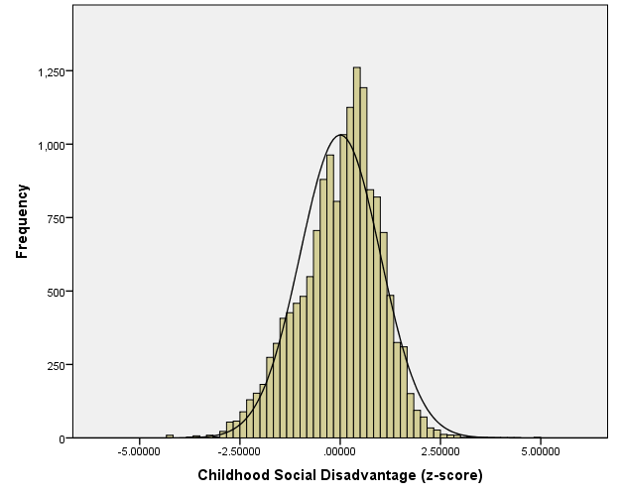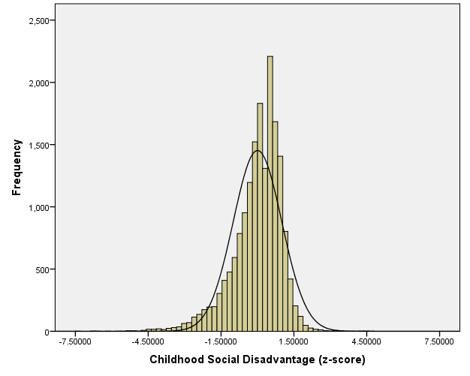

Figure S1: Histograms showing distribution of standardised measures of childhood social disadvantage in the NCDS (n = 15,509) and BCS (n = 17,486) cohorts.

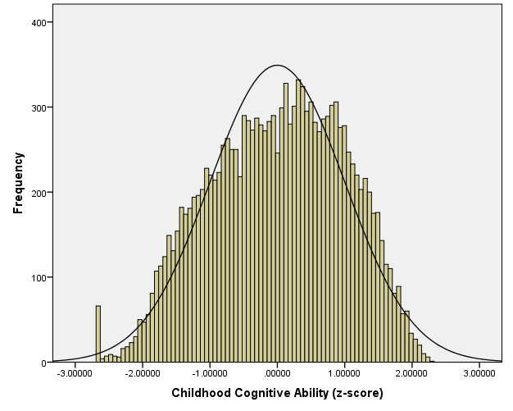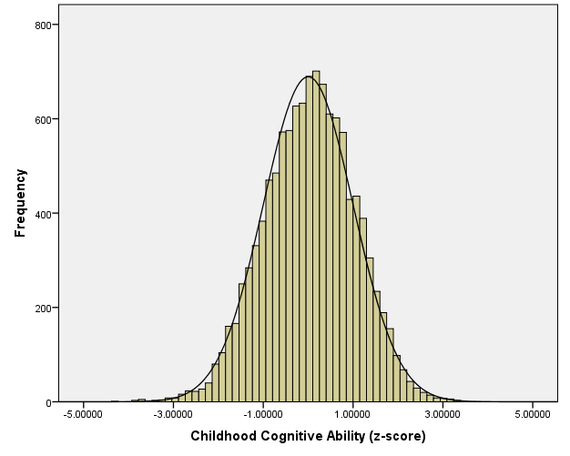

Figure S2: Histograms showing distribution of standardised measures of cognitive ability in the NCDS (n = 14,131) and BCS (n = 11,563) cohorts.